Price of Texas Universities 2008-2020

Elizabeth Morgan#1, Logan Hamilton#2

*#Computer Science Department, Stephen F Austin State University*

*Nacogdoches, Texas, United States of America*

1Morganeg@jacks.SFASU.edu

2hamiltonla3@jacks.SFASU.edu

***Abstract*— This document evaluates the price shifts for private and public universities in the state of Texas. The conclusions drawn only pertain to four year universities from the years 2008 to 2009, located in the state of Texas. Our analysis shows a slight stagnation for private colleges due to the 2008 recession, a definitive increase in price beyond the point of inflation for both types of universities, and a much steeper percentage increase for private universities over the 13 year period.**

***Keywords***— **College, Tuition, Inflation, College Prices, Change in tuition cost**

1. Introduction

Our data, provided by the Texas Higher Education Coordinating Board, or THECB, is a collection of self reported numbers relating to costs from colleges across Texas. After a preliminary filtering of our data, it includes 76 different colleges, and spans 13 years, from 2008 to 2020*. To keep comparisons consistent, we only focused on four-year universities and in-state tuition costs. Our data refers to a year as the school year in which the fall semester was in the year stated, so the 2008 year would be the 2008-2009 school year. All numbers submitted to the THECB are self-reported, and the data has been cleaned for continuity.

1. Raw Data

Prior to cleaning the data, we decided to run our analyses and create graphs based on the raw data given. This data showed an extreme stagnation between the years 2008 and 2009 for public universities, likely due to the 2008 recession. These two years only had a price increase of $270, the lowest estimate shift by far, with the second lowest being between 2019 and 2020 at $1039. Contrarily, public universities had their largest increase between 2008 and 2009, increasing an average of $1,018, compared to their second highest of $951 between 2011 and 2012. The trend of average prices for both categories of university can be seen in Figure 1. The blue and yellow lines in Figure 1 show the value the price would have been, on average per year, if the price stayed the average value from 2008 and simply increased to account for inflation.

Figure 1  
Raw Data - Averages

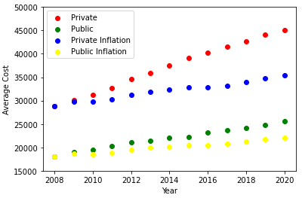

The raw data for private universities has a largest year over year change percentage of 5.83%, with an overall rate of change of 51.23%, and public universities had a high of 5.67%, with an overall rate of change of 42.66%. The prices, price changes, and their associated rates of change for all years, using cleaned data, can be seen in Table 1 for private universities, and Table 2 for public universities.

TABLE 1  
Year-to-Year Price Changes from Raw Data for Private Universities

| **Year** | **Price** | **Change in Price** | **Percent Change** |
| --- | --- | --- | --- |
| 2008 | $29,858 |  |  |
| 2009 | $30,129 | $271 | 0.91% |
| 2010 | $31,206 | $1,077 | 3.57% |
| 2011 | $32,662 | $1,456 | 4.67% |
| 2012 | $34,565 | $1,903 | 5.83% |
| 2013 | $35,962 | $1,397 | 4.04% |
| 2014 | $37,436 | $1,474 | 4.10% |
| 2015 | $39,069 | $1,633 | 4.36% |
| 2016 | $40,307 | $1,238 | 3.17% |
| 2017 | $41,507 | $1,200 | 2.98% |
| 2018 | $42,673 | $1,166 | 2.81% |
| 2019 | $44,096 | $1,423 | 3.33% |
| 2020 | $45,153 | $1,057 | 2.40% |

TABLE 2  
Year-to-Year Price Changes from Raw Data for Public Universities

| **Year** | **Price** | **Change in Price** | **Percent Change** |
| --- | --- | --- | --- |
| 2008 | $17,979 |  |  |
| 2009 | $18,998 | $1,019 | 5.67% |
| 2010 | $19,473 | $475 | 2.50% |
| 2011 | $20,210 | $737 | 3.78% |
| 2012 | $21,162 | $952 | 4.71% |
| 2013 | $21,473 | $311 | 1.47% |
| 2014 | $21,977 | $504 | 2.35% |
| 2015 | $22,264 | $287 | 1.31% |
| 2016 | $23,128 | $864 | 3.88% |
| 2017 | $23,623 | $495 | 2.14% |
| 2018 | $24,098 | $475 | 2.01% |
| 2019 | $24,797 | $699 | 2.90% |
| 2020 | $25,649 | $852 | 3.44% |

1. Data Cleaning

We began our data cleaning process by creating a graph to plot each college’s estimated cost, separated by year, to look for any severe outliers. This graph can be seen in Figure 2. This graph allowed us to individually investigate outliers, to do further research on them to see if they were accurate or were mistakes.

Figure 2  
Raw Data - All Averages

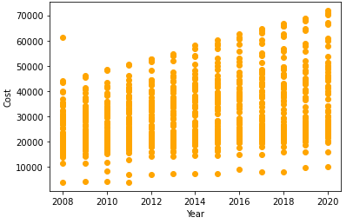

As seen, there is an extremely high outlier in 2008, with an estimated price a little over $60,000 with the second highest being only in the $45,000 range. After looking into this further, it seems that, due to the self-reported nature of this data, The College of Saints John Fisher and Thomas Moore made a typo in their 2008 submission. They submitted their average room and board for off-campus pricing was $45,000. For 2009 and 2010, they reported these numbers as $4,750 and $4,892, respectively. Using this information, we were able to infer that they meant to submit a price of $4,500. We decided the best course of action was to manually change this data to reflect our conclusion, changing the off-campus housing price to $4,500, and the average total to $20,775.

We also saw a consistent pack of two or three colleges sitting well below the clustered average. These were largely caused by low estimated expenses due to missing values. We only worried about colleges with missing values in columns that affected the end average we were using for our comparison model. These included resident tuition, books and supplies, off campus room and board, off campus transportation, and off campus personal expenses. A large portion of the time, a college was missing one or more of these values, such as Sul Ross State University Rio Grande College, which was missing three out of the four aforementioned values for four consecutive years, or Amberton University, which was missing all four values for 11 consecutive years.

We tried to resolve these while keeping the colleges in the data set by averaging the same category of other colleges, using the same year and within $1,000 above and below in their average tuition price. This, however, often yielded no colleges within the range, or one other college which was also missing the value needed. Instead, we decided to simply drop any entries missing a value in one of the columns. This only dropped 38 rows out of our entire data set, lowering us from 959 to 921 entries.

Figure 3 below shows a model of how many colleges submitted data each year, properly to scale to show the actual variation in total between years, with Figure 4 showing the same data with a smaller y-axis limitation, for an easier read of numbers and comparison.

Figure 3  
Records by Year

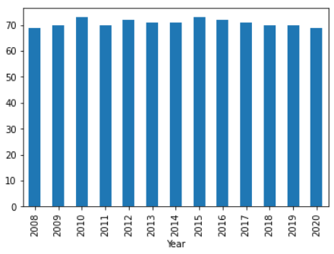

Figure 4  
Records by Year - Limited Y-Axis

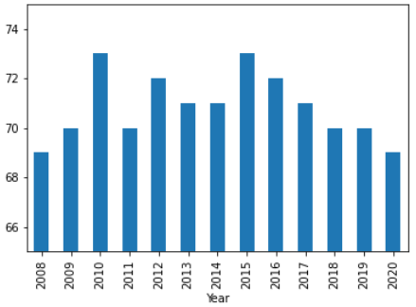

1. Proposed Findings

Our data shows consistent upward trends in price for both private and public Texas universities, with private universities having both a higher average cost and a steeper increase curve year-to-year. Private universities were still affected by the 2008 recession, however, to a much lower degree than before. With a stagnation in price causing an increase of only $1,142, the 2008 to 2009 price differentiation is the second lowest change, only behind a $544 increase between 2012 and 2013. Public universities, in contrast, had their largest change between 2008 and 2009, with a total price increase of $1,043, the second highest being 2014 to 2015 at $863. Tables 3 and 4 show the prices, change in dollars, and percent change between years, using the cleaned data set, for private and public colleges respectively.

TABLE 3  
Year-to-Year Price Changes from Cleaned Data for Private Universities

| **Year** | **Price** | **Change in Price** | **Percent Change** |
| --- | --- | --- | --- |
| 2008 | $28,807 |  |  |
| 2009 | $29,949 | $1,142 | 3.96% |
| 2010 | $31,644 | $1,695 | 5.66% |
| 2011 | $34,092 | $2,448 | 7.74% |
| 2012 | $35,777 | $1,685 | 4.94% |
| 2013 | $36,321 | $544 | 1.52% |
| 2014 | $38,675 | $2,354 | 6.48% |
| 2015 | $39,999 | $1,324 | 3.42% |
| 2016 | $41,198 | $1,199 | 3.00% |
| 2017 | $42,578 | $1,380 | 3.35% |
| 2018 | $43,891 | $1,313 | 3.08% |
| 2019 | $45,761 | $1,870 | 4.26% |
| 2020 | $47,110 | $1,349 | 2.95% |

TABLE 4  
Year-to-Year Price Changes from Cleaned Data for Public Universities

| **Year** | **Price** | **Change in Price** | **Percent Change** |
| --- | --- | --- | --- |
| 2008 | $18,390 |  |  |
| 2009 | $19,433 | $1,043 | 5.67% |
| 2010 | $19,881 | $448 | 2.31% |
| 2011 | $20,649 | $768 | 3.86% |
| 2012 | $21,302 | $653 | 3.16% |
| 2013 | $21,622 | $320 | 1.50% |
| 2014 | $21,977 | $355 | 1.64% |
| 2015 | $22,264 | $287 | 1.31% |
| 2016 | $23,128 | $864 | 3.88% |
| 2017 | $23,623 | $495 | 2.14% |
| 2018 | $24,098 | $475 | 2.01% |
| 2019 | $24,797 | $699 | 2.90% |
| 2020 | $25,649 | $852 | 3.44% |

Figure 5 is a recreation of Figure 1 above, however, this time, using our cleaned data. The green and purple lines represent the average price from 2008, if it was raised every year to only account for inflation.

Figure 5  
Clean Data - Averages

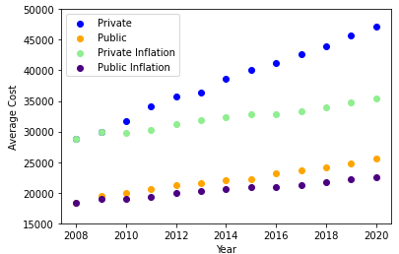

It shows private colleges seem to almost perfectly hit their inflation rate value for 2009, before jumping from it in 2010, and continuing a much steeper climb than inflation. Public colleges immediately deviate from the inflation set, and instead steadily creeps further from it each year.

1. Conclusion

Our final data set spans 13 years from 2008 to 2020, and includes records for a high of 73 colleges in 2010 and 2015, to a low of 69 colleges in 2008 and 2020.

Our data shows a massive, exponentially increasing price difference between private and public colleges in the state of Texas. It also shows an extreme disparity between the inflation rate and the rate of increase for private colleges, as well as a significantly smaller difference for the increase between inflation rate and public college price increases.

Our data shows a usual cluster of prices spanning approximately $25,000, with more gaps in the cluster and colleges sitting above the cluster as time progresses, as well as a single college, Southwestern Christian College, which sits slightly below the cluster for 9 out of the 13 years.

1. Future Work

Future work could be done on this data by using other gathered data on demographic makeups and applying it to the data currently used to better predict prices for future years for individual colleges, or using the current data to predict future average prices for all colleges across the state. Additional data could include things such as distance from a college to the nearest major city (a city with a population greater than 250,000), the college’s student population and diversity makeup, average income of the city the college is located in, as well as the city’s average income per household.

Acknowledgment

We would like to acknowledge the Texas Higher Education Coordinating Board for gathering and providing the data used, and the U.S. Bureau of Labor Statistics for the yearly average inflation rate. Finally, we would also like to acknowledge, and thank, Dr. Dipak Singh for his guidance and teachings throughout this semester.

References

1. “Consumer Price Index Data from 1913 to 2021: US Inflation Calculator.” US Inflation Calculator |, 13 Apr. 2021, www.usinflationcalculator.com/inflation/consumer-price-index-and-annual-percent-changes-from-1913-to-2008/..
2. Pon, Ken. “Tuition and Fees Data.” THECB, Texas Higher Education Coordinating Board, www.highered.texas.gov/institutional-resources-programs/funding-facilities/tuition-and-fees-data/.